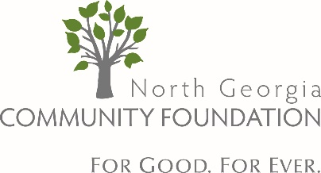
For more information:
Michelle Prater, President & CEO
North Georgia Community Foundation
615 F Oak Street, Suite 1300
Gainesville, GA 30501
E-mail: mprater@ngcf.org
Phone: 770-535-7880

FOR IMMEDIATE RELEASE May 8, 2020

“In Just Over a Month, NGCF has Awarded Over $415,000 in COVID-19 Relief”

Since establishing their COVID-19 Relief Fund, the North Georgia Community Foundation (NGCF) has awarded over $415,000 in emergency grants to nonprofits across North Georgia. Michelle Prater, NGCF President & CEO, said “Along with setting aside all of our 2020 grant funding for COVID-19 relief, we have had incredible support from people and organizations in our community who want to help. This additional support has been received through matching grant opportunities, gifts from private foundations and individuals, specific projects benefitting our fund such as the ‘Good People of Gainesville’ campaign and the Chattahoochee Riverkeepers Wild & Scenic Film Festival, as well as generous contributions from NGCF fundholders, board members, and staff.”
“NGCF has been flooded with requests from nonprofits needing immediate assistance and the volume of calls has not slowed down. We are thankful for all of those that have given quickly in response to the emergency needs in our community, and we encourage others to continue to follow their example and make contributions to support our relief efforts. Each donation will make a huge difference in the impact we can make for those in our community that are hurting during this time.”
To donate to the NGCF Coronavirus (COVID-19) Relief Fund and learn more about the grants given, visit: www.ngcf.org/covid19relief. For questions on making contributions – and nonprofits requesting help, contact Michelle Prater directly at mprater@ngcf.org.

